In order to reduce operational cost and increase productivity automated application that manages restaurant business is required especially restaurants are spread all over the country nowadays also the number of customers is in increase and choices of products are getting more and more, eventually, staff can focus more on costumes which will make them happy and motivate them to come back.

Usually, restaurants have branches in different locations and each of these is considered as a separate unit so they have there own employees and budget, one customer visit many branches and many customers may visit one branch, each customer make order or orders

Restaurant has information (id, country, name).

Each restaurant has many branches, Branch has information (id, address( city, street, building number), name, phone numbers).

For each Branch there are many Staff, Staff has information (id, name( last name, first name, middle name), address( street, city, building number), phone numbers, date of birth, salary, over time, nationality, email, position).

Restaurant has many Customers, Customer may visit many branches, each customer has information (id, name( first name, middle name, last name), phone numbers, address( street, city, building number), email).

The restaurant provides multiple types of Item. each Item has (id, name, price).

customer can make many orders, each Order_table has information (number, date, remark, branch id), each Order has many Items, while the Item can be found in multiple Orders.

Business needs and user groups:

Management needs to see the Customers, Branches Staff and Orders.

Finance needs to see the Order and Item to get invoices.

Kitchen staff need to see the Order and Item to prepare ordered items.

Floor staff need to see Order and Item to enter and follow orders until delivered to the customer.

1. Management
   1. Restaurant owner:
      1. the customer with most orders,

SELECT DISTINCT customer.first_name,customer.middle_name,customer.last_name, COUNT(order_table.Customer_id)order_counter from order_table,customer WHERE customer.id = order_table.Customer_id GROUP BY order_table.Customer_id

* + 1. list of all staff per branch

SELECT * FROM staff, branch WHERE branch.id = staff.branch_id ORDER by branch.id, staff.id

* + 1. list of all items

SELECT * FROM item

* 1. Branch manager:
     1. the customer with most orders for his own branch

select DISTINCT customer.*, count( order_table.date) number_of_orders FROM customer inner join branch_customer on (customer.id=branch_customer.id and branch_customer.Branch_id= (SELECT staff.branch_id FROM staff WHERE staff.position = REPLACE(CURRENT_USER, '@localhost',''))) INNER JOIN order_table on customer.id = order_table.Customer_id GROUP BY order_table.Customer_id

* + 1. list of all staff per branch for his own branch

SELECT * FROM staff WHERE staff.branch_id = (SELECT staff.branch_id FROM staff WHERE staff.position = REPLACE(CURRENT_USER, '@localhost','')) ORDER BY staff.id

1. Finance
   1. Cashier:

* + 1. needs to see the Order and Item to get a list of orders per date

To get the order number that he needs to get ht einvoice for it later on, in his branch

SELECT DISTINCT order_table.number, order_table.date,order_table.remark,item_order_table.quantity,item.name FROM order_table,item_order_table, item WHERE order_table.number= item_order_table.order_table_number AND item.id= item_order_table.item_id and order_table.branch_id = (SELECT staff.branch_id FROM staff WHERE staff.position = REPLACE(CURRENT_USER, '@localhost',''))

* + 1. Invocise for a specific order number in his branch

SELECT DISTINCT order_table.number, order_table.date,order_table.remark,item_order_table.quantity,item.name,item_order_table.price FROM order_table,item_order_table, item WHERE order_table.number= item_order_table.order_table_number AND item.id= item_order_table.item_id and order_table.branch_id = (SELECT staff.branch_id FROM staff WHERE staff.position = REPLACE(CURRENT_USER, '@localhost','')) and order_table.date = '2020-03-28' group by item_order_table.item_id UNION ALL SELECT 'Total', ' ',' ',' ',' ',sum(item_order_table.price) FROM order_table,item_order_table, item WHERE order_table.number= item_order_table.order_table_number AND item.id= item_order_table.item_id and order_table.branch_id = (SELECT staff.branch_id FROM staff WHERE staff.position = REPLACE(CURRENT_USER, '@localhost','')) and order_table.date = '2020-03-28' group by item_order_table.order_table_number

1. Kitchen staff
   1. Chief:
      1. need to see order and item to prepare the order per date in his branch

SELECT DISTINCT order_table.date,order_table.remark,item_order_table.quantity,item.name FROM order_table,item_order_table, item WHERE order_table.number= item_order_table.order_table_number AND item.id= item_order_table.item_id and order_table.branch_id = (SELECT staff.branch_id FROM staff WHERE staff.position = REPLACE(CURRENT_USER, '@localhost','')) AND order_table.date = '2020-03-28')

1. Floor staff
   1. Waitress:
      1. needs to see the Order and Item to get a list of orders per date

To get the order number that he needs to get ht einvoice for it later on , in his branch

SELECT DISTINCT order_table.number, order_table.date,order_table.remark,item_order_table.quantity,item.name FROM order_table,item_order_table, item WHERE order_table.number= item_order_table.order_table_number AND item.id= item_order_table.item_id and order_table.branch_id = (SELECT staff.branch_id FROM staff WHERE staff.position = REPLACE(CURRENT_USER, '@localhost',''))

* + 1. Invocise for a specific order number in his branch ,user should enter the order number as in red below example :

SELECT DISTINCT order_table.number, order_table.date,order_table.remark,item_order_table.quantity,item.name,item_order_table.price FROM order_table,item_order_table, item WHERE order_table.number= item_order_table.order_table_number AND item.id= item_order_table.item_id and order_table.branch_id = (SELECT staff.branch_id FROM staff WHERE staff.position = REPLACE(CURRENT_USER, '@localhost','')) and order_table.number= 3 group by item_order_table.item_id UNION ALL SELECT 'Total', ' ',' ',' ',' ',sum(item_order_table.price) FROM order_table,item_order_table, item WHERE order_table.number= item_order_table.order_table_number AND item.id= item_order_table.item_id and order_table.branch_id = (SELECT staff.branch_id FROM staff WHERE staff.position = REPLACE(CURRENT_USER, '@localhost','')) and order_table.number = 3 group by item_order_table.order_table_number

Mapping

1. Restaurant (id, country, name).
2. Branch (id, city, street, building number, name, restaurant_id).
3. Branch_phone (branch_id, phone)
4. Branch-customer(Branch-id, customer-id,id)
5. Staff (id, last name, first name, middle name, street, city, building number, date of birth, salary, over time, nationality, email, position, branch_id).
6. Staff_phone(staff_id, phone,Branch_id)
7. Customer (id, first name, middle name, last name, street, city, building number, email, restaurant_id).
8. Customer_phone(customer_id, phone)
9. Item (id, name, price, restaurant_id)
10. Item-Order_table (id, number, price, quantity)
11. Order_table (number, date, remark, Customer_id, branch_id)

Restaurant application

V1.0

User manual

Table of content

1. Introduction
2. Business description
   1. How to install WAMP-server
   2. How to use WAMP-server
3. Database
4. User functionality
5. **Introduction**
6. Purpose

The purpose of this application is to provide the restaurant with a solution that automates the process of restaurant functionality in the scoop of registering the customers, making orders and providing invoices

1. Scope

In order to reduce operational cost and increase productivity automated application that manages restaurant business is required especially restaurants are spread all over the country nowadays also the number of customers is in increase and choices of products are getting more and more, eventually, staff can focus more on costumes which will make them happy and motivate them to come back.

Usually, restaurants have branches in different locations and each of these is considered as a separate unit so they have there own employees and budget, one customer visit many branches and many customers may visit one branch, each customer make order or orders

1. Overview

Restaurant has information (id, country, name).

Each restaurant has many branches, Branch has information (id, address( city, street, building number), name, phone numbers).

For each Branch there are many Staff, Staff has information (id, name( last name, first name, middle name), address( street, city, building number), phone numbers, date of birth, salary, over time, nationality, email, position).

Restaurant has many Customers, Customer may visit many branches, each customer has information (id, name( first name, middle name, last name), phone numbers, address( street, city, building number), email).

The restaurant provides multiple types of Item. each Item has (id, name, price).

customer can make many orders, each Order_table has information (number, date, remark, branch id), each Order has many Items, while the Item can be found in multiple Orders.

1. **Business description**

This application is designed at this stage for users to enter and run their requirements through WAMP-server in order to get the reports that they need.

Refer to step ‘how to install WAMP-server ‘ for more information.

The application deals with Mysql and My PHP alongside storing the data for them in a database to be retrieved later on according to user functionality.

Consider the following points before using the system

1. The application administrator should install the database previously the application restaurant database including the user privileges
2. The system administrator should enter the restaurant and owner detailed record
3. **How to install WAMP-server.**

**In order to install WAMP-server**

1. Windows is a requirement for WAMP-server
2. Download WAMP-server from here <https://www.wampserver.com/en/>
3. Chose the download according to what bit system do have 64 or 32
4. Open the wampserver3.2.0_x64.exe then chose you language
5. Press ok
6. Then approved on the agreement 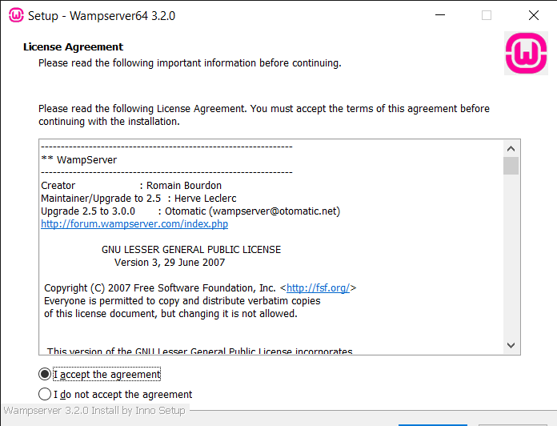
7. Press next
8. This screen will show the required component for installation after you read them press nex
9. Chose the location for it to install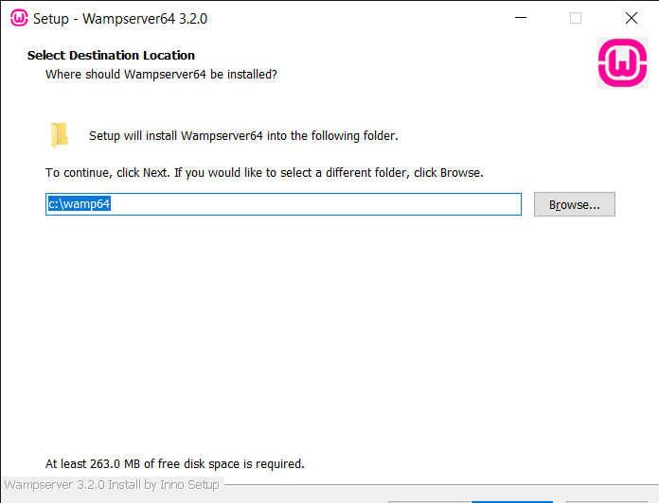
10. Press next then chose the location for the shortcut
11. Press install then next then finish

B. how to use WAMP-server

1. Run WAMP-server by pressing on the WAMP-server shortcut
2. A browser of your choice will open automatically and show the login details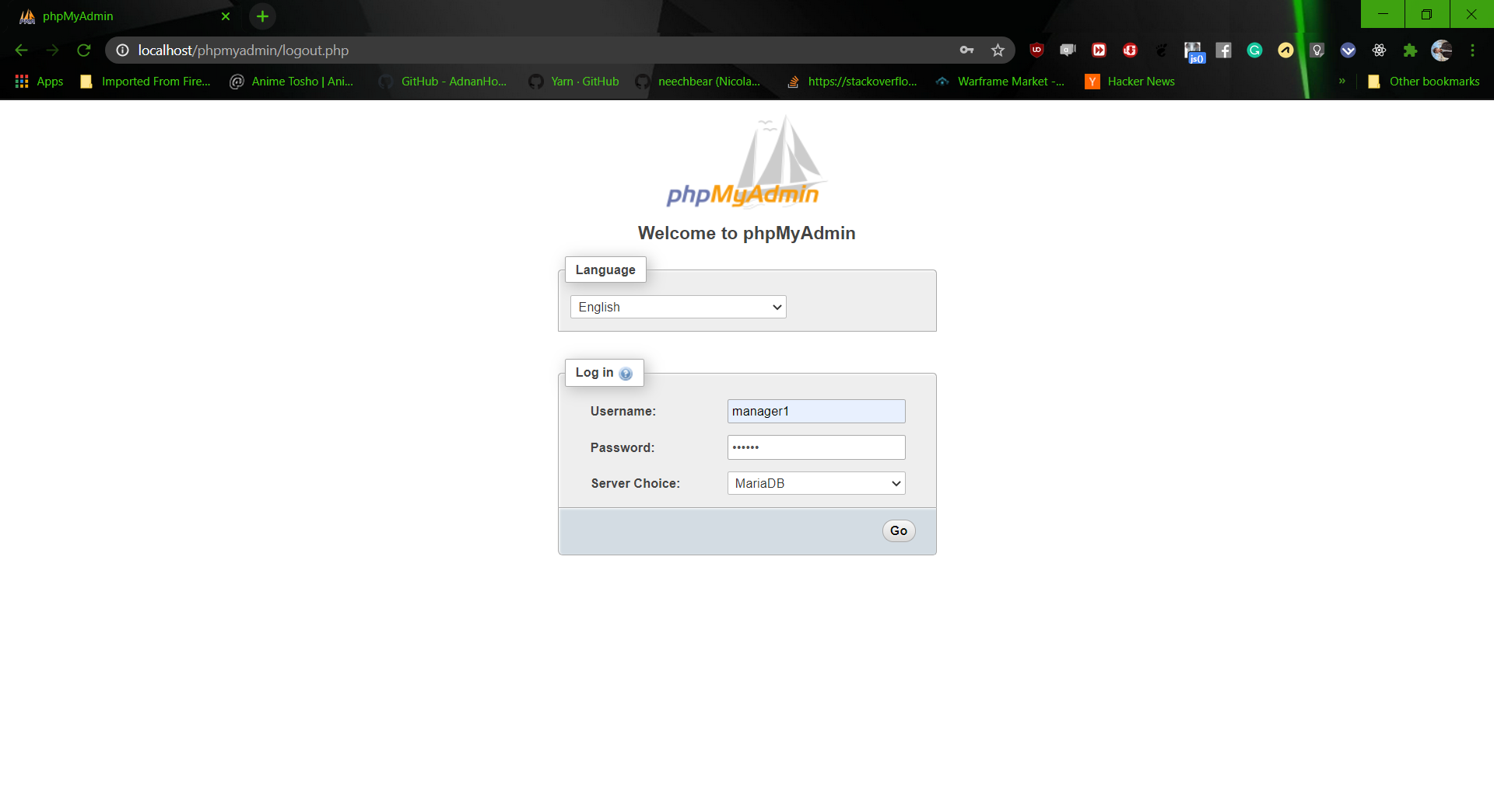
3. Enter the login detail alongside the password each in its place then press enter
4. A different screen will open on the left you will find the database available above that on the left you will find the home, logout, help… on the top from mid to right you will find navigation buttons there chose the database restaurant from left 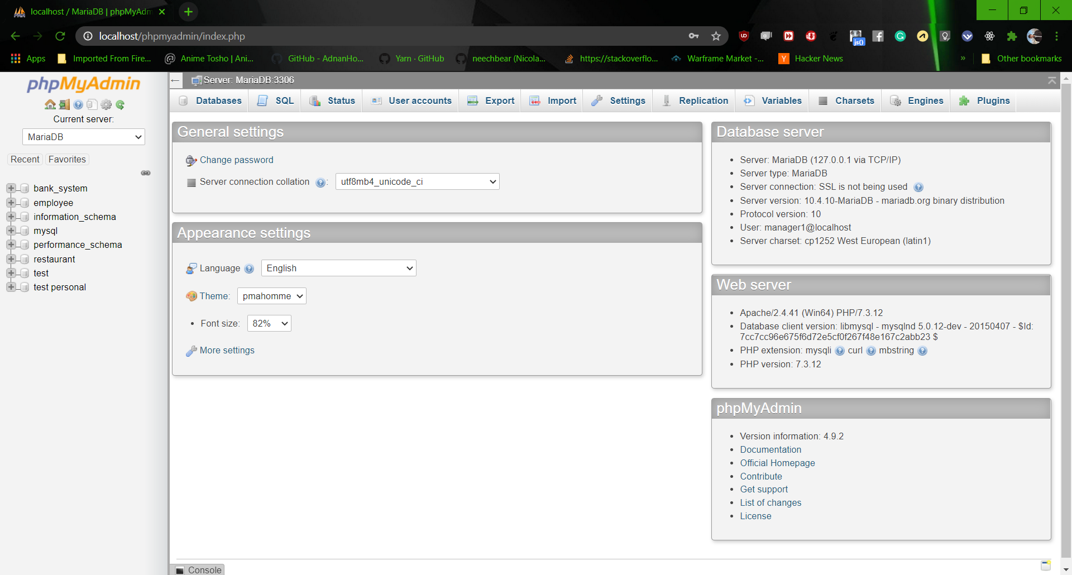
5. Navigate to the SQL in the top mid of the screen
6. Under the navigation tab you will find a place to write some text like the select statement used to get the queries and insert, update (as in the screenshot below after you have written the statements you can press go you will get the something simulate to the result below )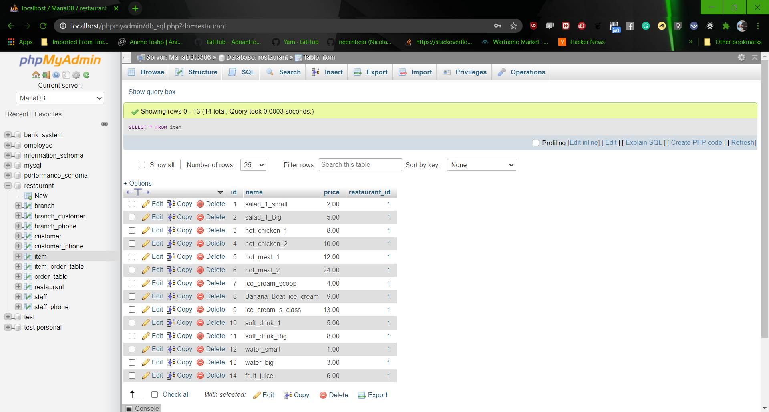

3. **Database maping**

Restaurant (id, country, name).

Branch (id, city, street, building number, name, restaurant_id).

Branch_phone (branch_id, phone)

Branch-customer(Branch-id, customer-id,id)

Staff (id, last name, first name, middle name, street, city, building number, date of birth, salary, over time, nationality, email, position, branch_id).

Staff_phone(staff_id, phone,Branch_id)

Customer (id, first name, middle name, last name, street, city, building number, email, restaurant_id).

Customer_phone(customer_id, phone)

Item (id, name, price, restaurant_id)

Item-Order_table (id, number, price, quantity)

Order_table (number, date, remark, Customer_id, branch_id)

4. **User functionality**

Each user has a role in the application, user should copy the statement according to functionality and past it in the SQL section in WAMP-server then edit or change the variables int the statement according to the required the press go, following are the responsibilities of each user according to there business function

1. **Owner**
   1. defines the items example :

INSERT INTO item(`id`,`name`,`price`,`restaurant_id`) VALUES(2, 'salad_1_Big',5,1 )

* 1. Define branch example :

INSERT INTO branch(`id`,`city`,`street`,`building_number`,`name`,`restaurant_id`) VALUES(1,'amman', 'hasan mohamad','44','byader', 1)

* 1. Report customer with most orders example :

SELECT DISTINCT customer.first_name,customer.middle_name,customer.last_name, COUNT(order_table.Customer_id)order_counter from order_table,customer WHERE customer.id = order_table.Customer_id GROUP BY order_table.Customer_id

* 1. Report list of all staff per branch example:

SELECT * FROM staff, branch WHERE branch.id = staff.branch_id ORDER by branch.id, staff.id

* 1. Report list of all items example :

SELECT * FROM item

1. **Branch manager**
   1. Define staff details of his branch

INSERT INTO staff(`id`,`last_name`,`first_name`,`middle_name`,`street`,`city`,`building_number`,`date_of_birth`,`salary`,`over_time`,`nationality`,`email`,`position`,`branch_id`) VALUES(4,'alsaed','ali', 'sleman','golf.st', 'amman',3, '1989-01-01',300, 22,'jordanien','ali.alsaed@gmail.com','Waiter', 1 )

* 1. Report the customer with most orders for his own branch example

select DISTINCT customer.*, count( order_table.date) number_of_orders FROM customer inner join branch_customer on (customer.id=branch_customer.id and branch_customer.Branch_id= (SELECT staff.branch_id FROM staff WHERE staff.position = REPLACE(CURRENT_USER, '@localhost',''))) INNER JOIN order_table on customer.id = order_table.Customer_id GROUP BY order_table.Customer_id

* 1. Report list of all staff per branch for his own branch example :

SELECT * FROM staff WHERE staff.branch_id = (SELECT staff.branch_id FROM staff WHERE staff.position = REPLACE(CURRENT_USER, '@localhost','')) ORDER BY staff.id

3. **Chief**

1. need to see order and item to prepare the order per date in his branch ,user need to change the needed date as in red bellow Example:

SELECT DISTINCT order_table.date,order_table.remark,item_order_table.quantity,item.name FROM order_table,item_order_table, item WHERE order_table.number= item_order_table.order_table_number AND item.id= item_order_table.item_id and order_table.branch_id = (SELECT staff.branch_id FROM staff WHERE staff.position = REPLACE(CURRENT_USER, '@localhost','') AND order_table.date = '2020-03-28')

4. **Cashier/waitress**

* 1. define customer details example:

INSERT INTO customer(`id`,`first_name`,`middle_name`,`last_name`,`street`,`city`,`building_number`,`email`,`restaurant_id`) VALUES(3, 'kareem','amen', 'wasem', 'byader','amman', '7','kareem@test.com',1 )

* 1. Define customer phone example:

INSERT INTO customer_phone(`customer_id`,`phone`) VALUES(3,0789266566)

* 1. Define order details example:

INSERT INTO order_table(`number`,`date`,`remark`,`Customer_id`) VALUES(1,'2020-03-14','hot',1);

INSERT INTO item_order_table(`item_id`,`order_table_number`,`price`,`quantity`) VALUES(1,1,4,2);

* 1. Report of the list of orders per date in his branch to pick the order number that he needs to get the invoice for it later on, in his branch, user should enter the date as in red below example:

[SELECT](http://localhost/phpmyadmin/url.php?url=https://dev.mysql.com/doc/refman/5.5/en/select.html) DISTINCT order_table.number, order_table.date,order_table.remark,item_order_table.quantity,item.name FROM order_table,item_order_table, item WHERE order_table.number= item_order_table.order_table_number [AND](http://localhost/phpmyadmin/url.php?url=https://dev.mysql.com/doc/refman/5.5/en/logical-operators.html#operator_and) item.id= item_order_table.item_id [and](http://localhost/phpmyadmin/url.php?url=https://dev.mysql.com/doc/refman/5.5/en/logical-operators.html#operator_and) order_table.branch_id = ([SELECT](http://localhost/phpmyadmin/url.php?url=https://dev.mysql.com/doc/refman/5.5/en/select.html) staff.branch_id FROM staff WHERE staff.position = [REPLACE](http://localhost/phpmyadmin/url.php?url=https://dev.mysql.com/doc/refman/5.5/en/replace.html)([CURRENT_USER](http://localhost/phpmyadmin/url.php?url=https://dev.mysql.com/doc/refman/5.5/en/information-functions.html#function_current_user), '@localhost','')) [and](http://localhost/phpmyadmin/url.php?url=https://dev.mysql.com/doc/refman/5.5/en/logical-operators.html#operator_and) order_table.date ='2020-03-17'

* 1. Invoice for a specific order number in his branch, the user must enter the order number as in red below example:

SELECT DISTINCT order_table.number, order_table.date,order_table.remark,item_order_table.quantity,item.name,item_order_table.price FROM order_table,item_order_table, item WHERE order_table.number= item_order_table.order_table_number AND item.id= item_order_table.item_id and order_table.branch_id = (SELECT staff.branch_id FROM staff WHERE staff.position = REPLACE(CURRENT_USER, '@localhost','')) and order_table.number= 3 group by item_order_table.item_id UNION ALL SELECT 'Total', ' ',' ',' ',' ',sum(item_order_table.price) FROM order_table,item_order_table, item WHERE order_table.number= item_order_table.order_table_number AND item.id= item_order_table.item_id and order_table.branch_id = (SELECT staff.branch_id FROM staff WHERE staff.position = REPLACE(CURRENT_USER, '@localhost','')) and order_table.number = 3 group by item_order_table.order_table_number

**Technical manual**

V1.0

1. introduction
2. System overview
3. Database
   1. Database description
   2. ERD
4. Implementation
5. User definition
6. Reports
7. Introduction
8. System overview
9. Database
10. Database description

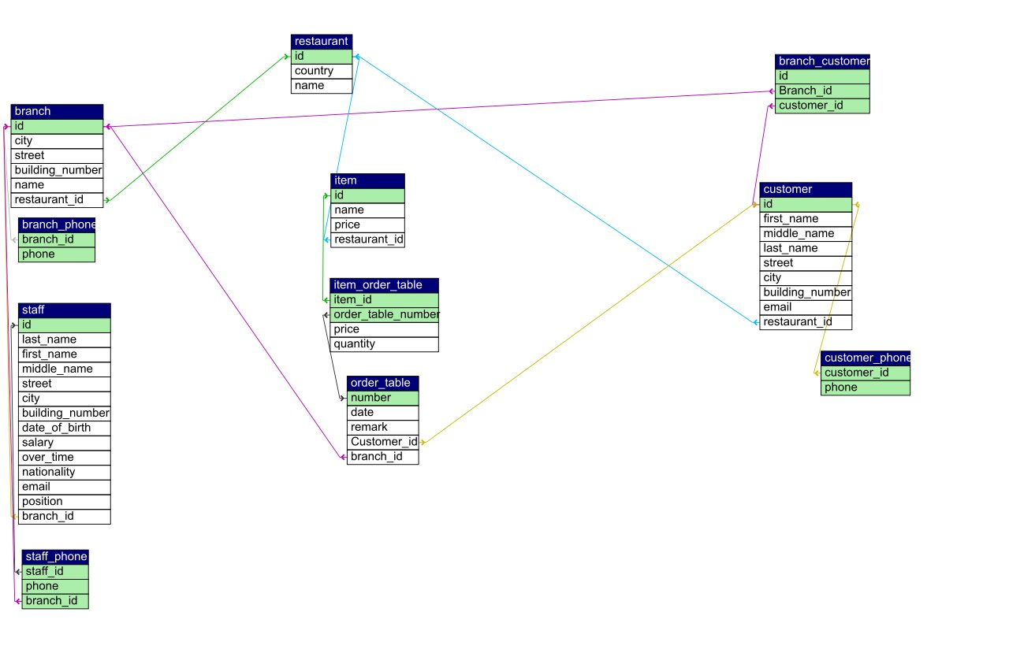

1. ERD

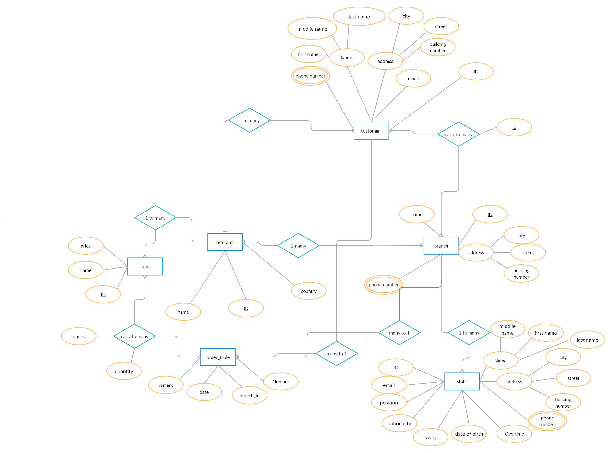

1. Implementation
   1. Run WAMP-server by pressing on the WAMP-server shortcut
   2. A browser of your choice will open automatically and show the login details
   3. Enter the login detail alongside the password each in its place then press enter
   4. A different screen will open on the left you will find the database available above that on the left you will find the home, logout, help… on the top from mid to right you will find navigation buttons there chose the database restaurant from left 
   5. Navigate to the SQL in the top mid of the screen
   6. Under the navigation tab you will find a place to write some text like the select statement used to get the queries and insert, update (as in the screenshot below after you have written the statements you can press go you will get the something simulate to the result below )

5. User privileges

| **Tables** | **Owner** | **Manager** | **Chief** | **Waitress** | **Cashier** |
| --- | --- | --- | --- | --- | --- |
| **Restaurant** | Full | Select |  |  |  |
| **Branch** | Full | Select |  |  |  |
| **Branch phone** | Full | Select |  |  |  |
| **Staff** | Full | Insert, select | Select | Select | Select |
| **Staff phone** | Full | Insert, select |  |  |  |
| **Customer** | Full | Select |  | Insert, select | Insert, select |
| **Customer phone** | Full | Select |  | Insert, select | Insert, select |
| **Branch customer** | Full | Select |  | Insert, select | Insert, select |
| **Order_table** | Full | Select | Update,select | Insert, select | Insert, select |
| **Item_order_table** | Full | Select | Select | Insert, select | Insert, select |
| **Item** | Full | Select | Select | Select | Select |

6. Reports

| **Report #** | **Description** | **Query** |
| --- | --- | --- |
| 1 | Customer with most orders | SELECT DISTINCT customer.first_name,customer.middle_name,customer.last_name, COUNT(order_table.Customer_id)order_counter from order_table,customer WHERE customer.id = order_table.Customer_id GROUP BY order_table.Customer_id |
| 2 | List of all items per branch | SELECT * FROM staff, branch WHERE branch.id = staff.branch_id ORDER by branch.id, staff.id |
| 3 | list of all items | SELECT * FROM item |
| 4 | the customer with most orders for his own branch | select DISTINCT customer.*, count( order_table.date) number_of_orders FROM customer inner join branch_customer on (customer.id=branch_customer.id and branch_customer.Branch_id= (SELECT staff.branch_id FROM staff WHERE staff.position = REPLACE(CURRENT_USER, '@localhost',''))) INNER JOIN order_table on customer.id = order_table.Customer_id GROUP BY order_table.Customer_id |
| 5 | list of all staff per branch for his own branch | SELECT * FROM staff WHERE staff.branch_id = (SELECT staff.branch_id FROM staff WHERE staff.position = REPLACE(CURRENT_USER, '@localhost','')) ORDER BY staff.id |
| 6 | need to see order and item to prepare the order per date in his branch ,user need to change the needed date | SELECT DISTINCT order_table.date,order_table.remark,item_order_table.quantity,item.name FROM order_table,item_order_table, item WHERE order_table.number= item_order_table.order_table_number AND item.id= item_order_table.item_id and order_table.branch_id = (SELECT staff.branch_id FROM staff WHERE staff.position = REPLACE(CURRENT_USER, '@localhost','') AND order_table.date = '2020-03-28') |
| 7 | Report of the list of orders per date in his branch to pick the order number that he needs to get the invoice for it later on, in his branch, user should enter the date | SELECT DISTINCT order_table.number, order_table.date,order_table.remark,item_order_table.quantity,item.name FROM order_table,item_order_table, item WHERE order_table.number= item_order_table.order_table_number AND item.id= item_order_table.item_id and order_table.branch_id = (SELECT staff.branch_id FROM staff WHERE staff.position = REPLACE(CURRENT_USER, '@localhost','')) and order_table.date ='2020-03-17' |
| 8 | Invoice for a specific order number in his branch, the user must enter the order number | SELECT DISTINCT order_table.number, order_table.date,order_table.remark,item_order_table.quantity,item.name,item_order_table.price FROM order_table,item_order_table, item WHERE order_table.number= item_order_table.order_table_number AND item.id= item_order_table.item_id and order_table.branch_id = (SELECT staff.branch_id FROM staff WHERE staff.position = REPLACE(CURRENT_USER, '@localhost','')) and order_table.number= 3 group by item_order_table.item_id UNION ALL SELECT 'Total', ' ',' ',' ',' ',sum(item_order_table.price) FROM order_table,item_order_table, item WHERE order_table.number= item_order_table.order_table_number AND item.id= item_order_table.item_id and order_table.branch_id = (SELECT staff.branch_id FROM staff WHERE staff.position = REPLACE(CURRENT_USER, '@localhost','')) and order_table.number = 3 group by item_order_table.order_table_number |

Testing paln

Part of the test plan isto run each one of the reports query as the folowing

1.0 1.

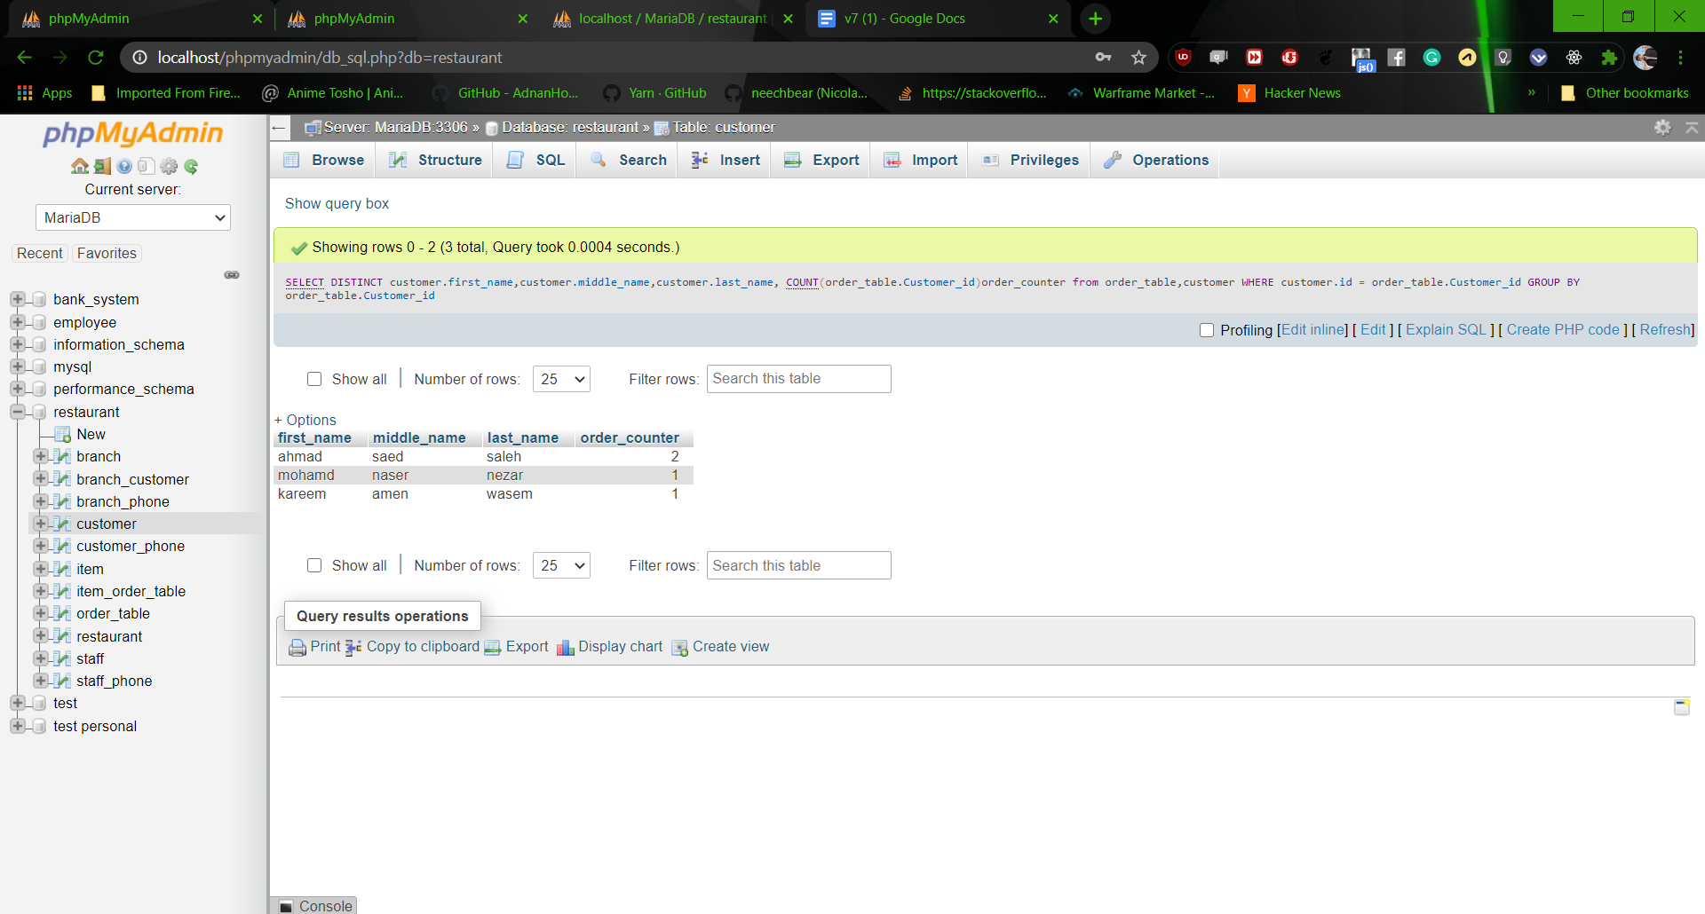

2. 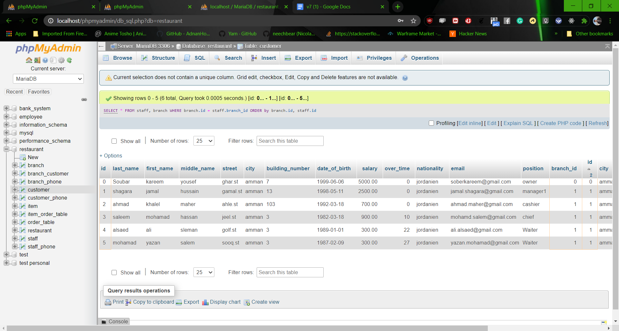

3. 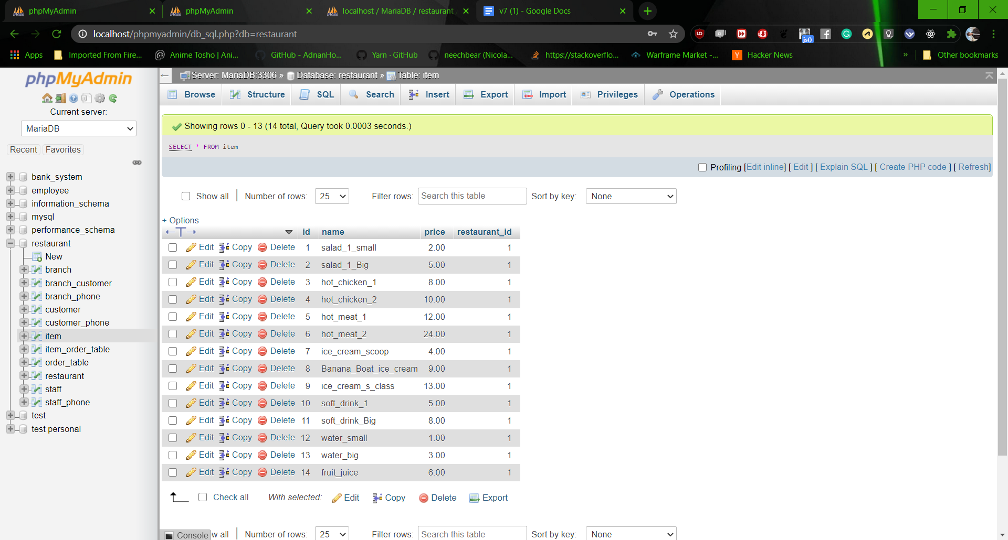

4.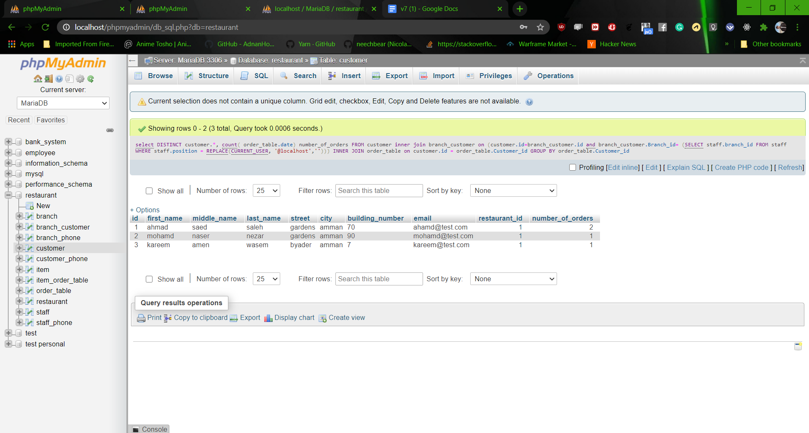

5.

6.

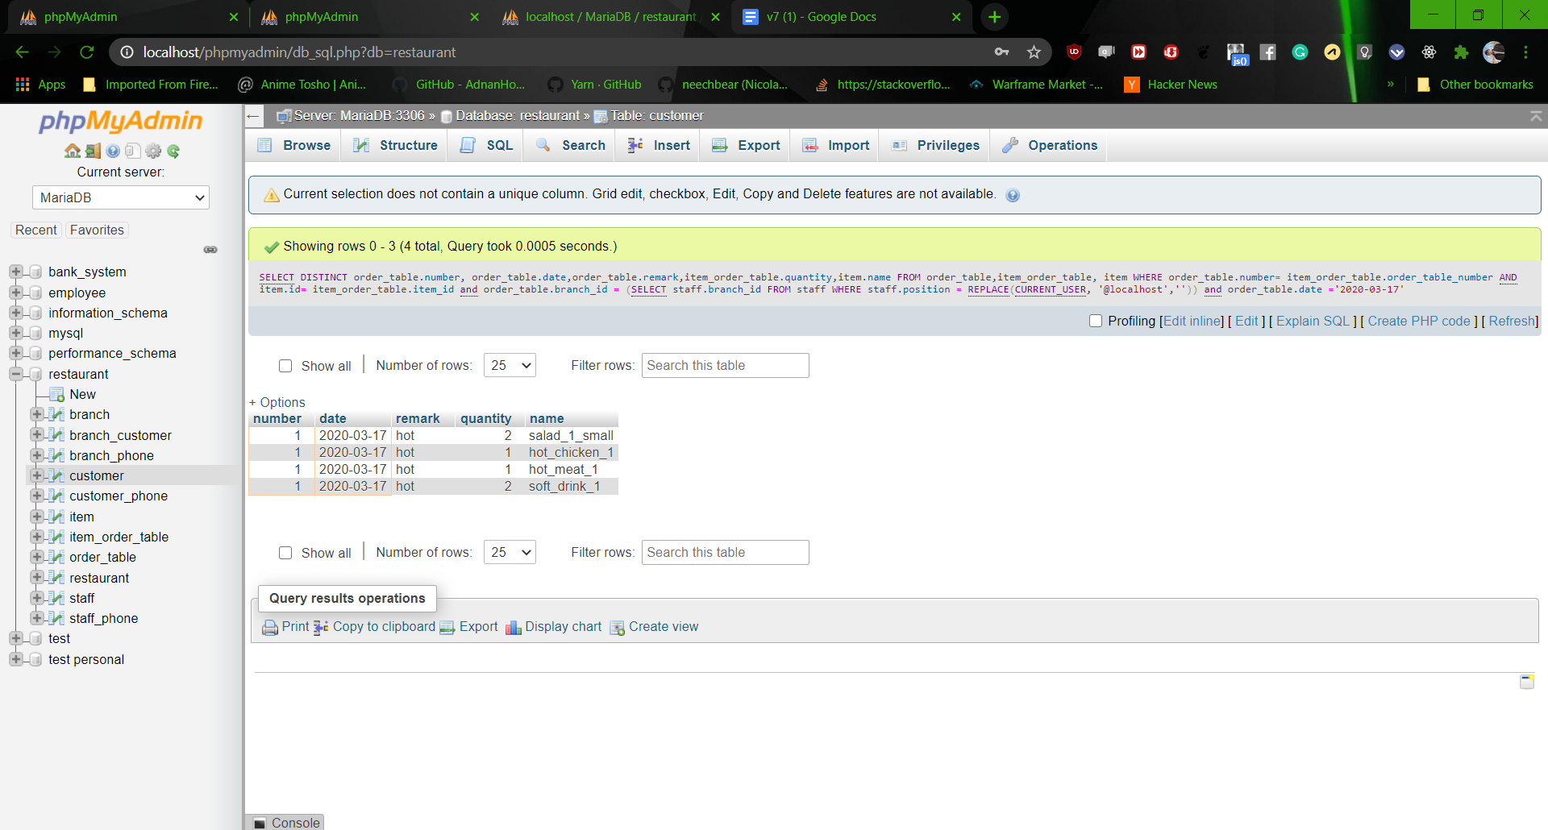

7.

8.

Also part of the test is to access table with no privilege as below

